Design and Analysis of Algorithms (23CSE211)

LAB ASSIGNMENT - 6

Name: Punamalli Sai Sanath Kumar
Roll No: CH.SC.U4CSE24237
Section: CSE-‘C’

1. Huffman Coding :
CODE:
#include <stdio.h>
#include <stdlib.h>

#define MAX 100

/* Structure for a Huffman Tree Node */
struct HuffNode {
char ch;
int freq;
struct HuffNode *left;
struct HuffNode *right;
};

/* Structure for Min Heap */
struct Heap {
int size;
struct HuffNode *data[MAX];
};

/* Function to create a new node */
struct HuffNode* createNode(char ch, int freq) {
struct HuffNode *node = (struct HuffNode*)malloc(sizeof(struct HuffNode));

node->ch = ch;
node->freq = freq;
node->left = NULL;
node->right = NULL;

return node;
}

/* Swap two nodes */
void swapNodes(struct HuffNode **a, struct HuffNode **b) {
struct HuffNode *temp = *a;
*a = *b;
*b = temp;
}

/* Heapify function to maintain min heap */
void heapify(struct Heap *heap, int i) {

int smallest = i;
int left = 2*i + 1;
int right = 2*i + 2;

if (left < heap->size && heap->data[left]->freq < heap->data[smallest]->freq)
smallest = left;

if (right < heap->size && heap->data[right]->freq < heap->data[smallest]->freq)
smallest = right;

if (smallest != i) {
swapNodes(&heap->data[i], &heap->data[smallest]);
heapify(heap, smallest);
}
}

/* Remove the smallest node from heap */
struct HuffNode* getMin(struct Heap *heap) {

struct HuffNode *temp = heap->data[0];

heap->data[0] = heap->data[heap->size - 1];
heap->size--;

heapify(heap, 0);

return temp;
}

/* Insert a node into heap */
void insertHeap(struct Heap *heap, struct HuffNode *node) {

int i = heap->size;
heap->size++;

while (i > 0 && node->freq < heap->data[(i-1)/2]->freq) {
heap->data[i] = heap->data[(i-1)/2];
i = (i-1)/2;
}

heap->data[i] = node;
}

/* Function to build Huffman Tree */
struct HuffNode* buildHuffmanTree(char letters[], int freq[], int n) {

struct Heap heap;
heap.size = 0;

/* Create initial heap nodes */
for (int i = 0; i < n; i++) {
heap.data[heap.size++] = createNode(letters[i], freq[i]);
}

/* Build the min heap */
for (int i = (heap.size/2) - 1; i >= 0; i--) {
heapify(&heap, i);
}

/* Repeat until only one node remains */
while (heap.size > 1) {

struct HuffNode *left = getMin(&heap);
struct HuffNode *right = getMin(&heap);

struct HuffNode *parent = createNode('*', left->freq + right->freq);

parent->left = left;
parent->right = right;

insertHeap(&heap, parent);
}

return getMin(&heap);
}

/* Function to print Huffman Codes */
void printCodes(struct HuffNode *root, int code[], int top) {

if (root->left) {
code[top] = 0;
printCodes(root->left, code, top + 1);
}

if (root->right) {
code[top] = 1;
printCodes(root->right, code, top + 1);
}

/* Leaf node means character found */
if (!root->left && !root->right) {

printf("%c : ", root->ch);

for (int i = 0; i < top; i++)
printf("%d", code[i]);

printf("\n");
}
}

/* Main function */
int main() {

char chars[] = {'A','B','C','D','E','F'};
int freq[] = {5,9,12,13,16,45};

int n = sizeof(chars)/sizeof(chars[0]);

struct HuffNode *root = buildHuffmanTree(chars, freq, n);

int code[MAX];
int top = 0;

printf("Huffman Codes:\n");

printCodes(root, code, top);

return 0;
}
OUTPUT:
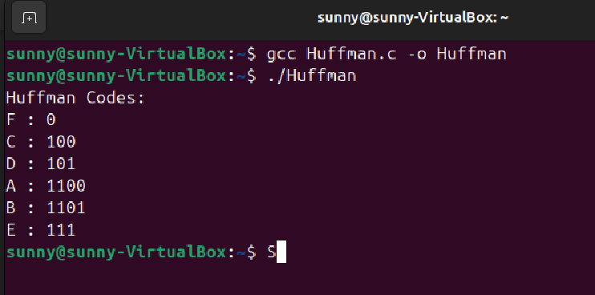
2. Job Sequencing
CODE:
#include <stdio.h>
#include <stdlib.h>

/* Structure to store job details */
struct Job {
int jobId;
int deadline;
int profit;
};

/* Function used by qsort to sort jobs by profit (descending order) */
int sortByProfit(const void *a, const void *b) {
struct Job *j1 = (struct Job *)a;
struct Job *j2 = (struct Job *)b;

return j2->profit - j1->profit;
}

int main() {

int n;

printf("Enter number of jobs: ");
scanf("%d", &n);

struct Job jobs[n];

/* Read job information */
for(int i = 0; i < n; i++) {
printf("Enter deadline and profit for Job %d: ", i+1);
scanf("%d %d", &jobs[i].deadline, &jobs[i].profit);

jobs[i].jobId = i + 1;
}

/* Sort jobs in decreasing order of profit */
qsort(jobs, n, sizeof(struct Job), sortByProfit);

/* Find the maximum deadline */
int maxDeadline = 0;
for(int i = 0; i < n; i++) {
if(jobs[i].deadline > maxDeadline)
maxDeadline = jobs[i].deadline;
}

/* Create time slots for scheduling jobs */
int slots[maxDeadline];

for(int i = 0; i < maxDeadline; i++)
slots[i] = -1;

int totalProfit = 0;

/* Schedule jobs */
for(int i = 0; i < n; i++) {

/* Try to place job in latest possible free slot */
for(int j = jobs[i].deadline - 1; j >= 0; j--) {

if(slots[j] == -1) {
slots[j] = jobs[i].jobId;
totalProfit += jobs[i].profit;
break;
}
}
}

/* Display scheduled jobs */
printf("\nSelected Jobs: ");

for(int i = 0; i < maxDeadline; i++) {
if(slots[i] != -1)
printf("J%d ", slots[i]);
}

printf("\nTotal Profit = %d\n", totalProfit);

return 0;
}
OUTPUT:
